4/28/2026
Somkhanda Gumbi
CMPE 324 Project
CMPE 324 Intermediate Report

Group members:
- 22302588 - Sinenkosi Somkhanda Gumbi – Computer Engineer
- 22114886 - Eraste Bololo Mata Lipwa - Computer Engineer
- 22205158 - Voiz Muzofirshoev - Computer Engineer
Selected platform: Arduino

Systems Block diagram
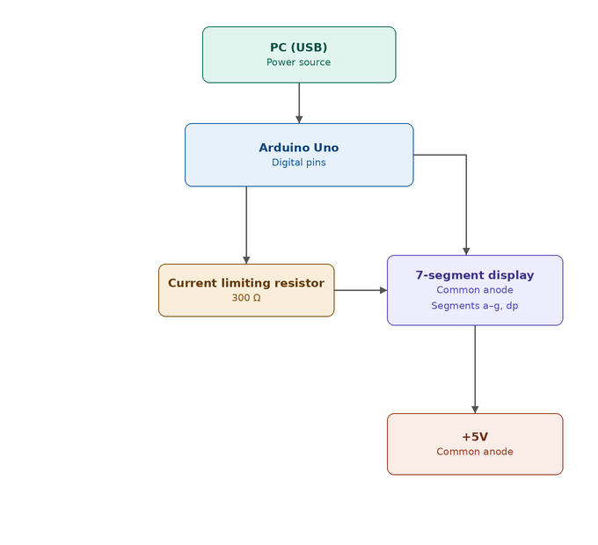
Components:
- 7 segment display (anode)
- Arduino uno
- Breadboard
- 7 Resistors (220/330/380 Ω) [plan to a single use - 330 Ω]

Initial circuit design:
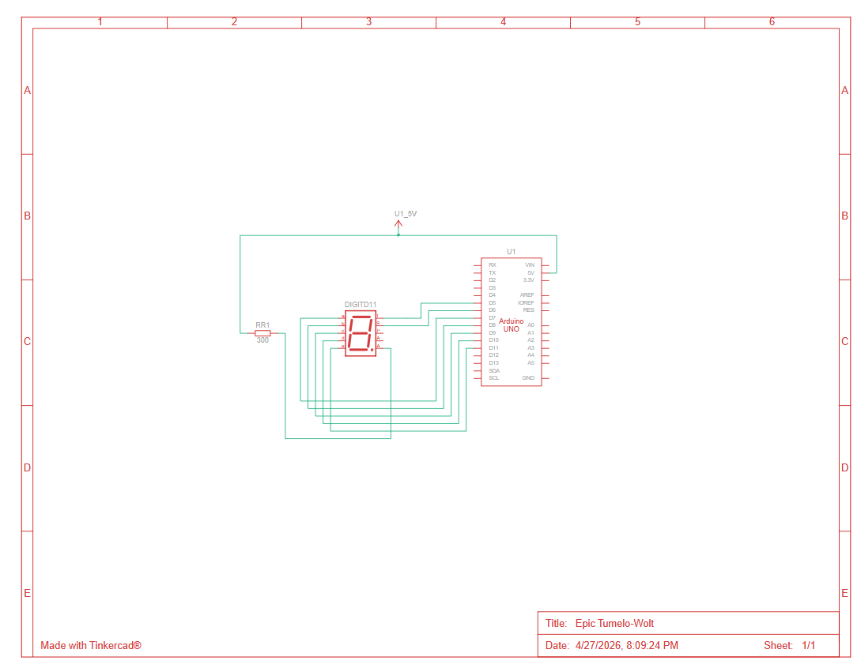Flow Chart